GAME 1011 - Advanced Programming

Assignment 1 (10%)

**Due: February 19th at 11:59pm**

# Requirements

Working in **groups of 1-3 people** create a RPG-style battle simulation. You must implement the following hierarchy (shown below) and adhere to the battle simulation described on the next page.

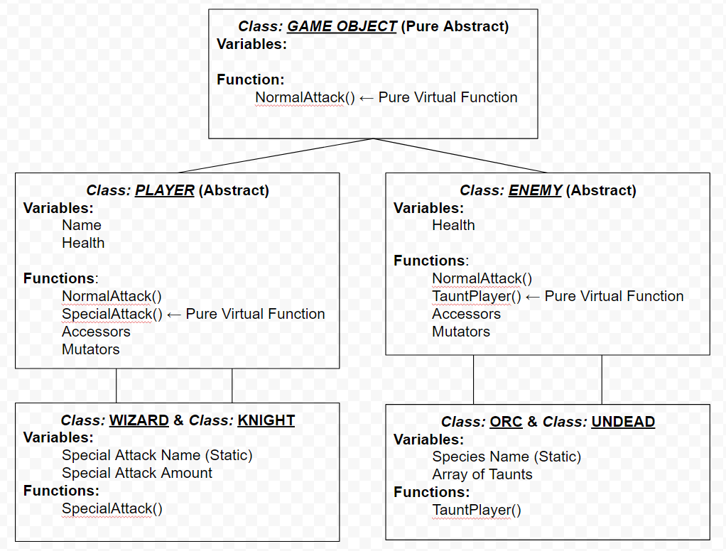

**NOTE:** There is a total of 7 classes (GameObject, Player, Enemy, Wizard, Knight, Orc, Undead)

# Battle Simulation Order

Your game will execute in the following order:

* Welcome message to player.
* Prompt the player for the following information

🌕 What type of player do they want to play as? Wizard or Human?

🌕 What is their character name?

* Provide a summary of the player information

🌕 Player Type

🌕 Player Names

🌕 Default health

* Ask the user if they are ready to witness a battle
* Your game **automatically** displays a battle between the created player and a randomly created enemy (1 of the 2 defined). Display all associated information about the enemy
* Battle sequence:

🌕 Enemy will taunt the player

🌕 Player performs a **normal attack**

🌕 Enemy will taunt the player

🌕 Player performs a **special attack**

🌕 Enemy performs normal attack

🌕 Enemy performs normal attack

🌕 Player performs **special attack**

🌕 Enemy taunts the player

🌕 Player performs **special attack**

🌕 Enemy dies

🌕 Win message

# Project Structure

Ensure your project adheres to professional coding standards learned in this program.

Ensure that all classes created contain both a **header (.h) and cpp (.cpp)** files where applicable.

# Submission

* **Working project to Blackboard**.